Lab 1: Linear Regression

ENSF 611 W2020

Instructor: Aysa Fakheri Tabrizi

Name: Asif Bux

UCID: 30031140

Welcome to Lab1!

* Check that you have a working python installation.
* We will use pip to install some packages. First get and install pip from [here](https://pip.pypa.io/en/latest/installing.html).
* Using pip, install python packages:
  + go to your terminal line (don’t open python, just the command prompt)
  + install sklearn: ***pip install scikit-learn***

-- for your reference, [here’s](http://scikit-learn.org/stable/install.html)the sklearn installation instructions

* Download the provided starter code.
* Add your answers to this manual in a different color.
* After adding your answers, create a pdf file and submit it to D2L dropbox.
* You don’t need to submit your python files.
* Deadline for submission is Monday January 27th, 11:59 pm.

In this lab, you will use regression to predict financial data for Enron employees and associates. Once you know some financial data about an employee, like their salary, what would you predict for the size of their bonus?

1. Run the starter code found in *regression/finance_regression.py*. This will draw a scatterplot, with all the data points drawn in.  **What target are you trying to predict? What is the input feature being used to predict it?(2)**

**The target we are trying to predict is the bonus on the y-axis. The input feature is the on the x-axis which is the Salary.**

1. Print out the scatterplot and use paper and pencil and sketch out the regression line that you roughly predict. (Or make a screenshot and draw on that).

**Attach the plot with your sketched out regression here: (2)**

1. In regression, you need training and testing data. **Change the color of test data from blue to red and rerun**. You will be fitting your regression using the blue (training) points only. (You may have noticed that instead of the standard 20%, we’ve put 50% of our data into the test set--that’s because later, we will switch the training and testing datasets around and splitting the data evenly makes this more straightforward.)

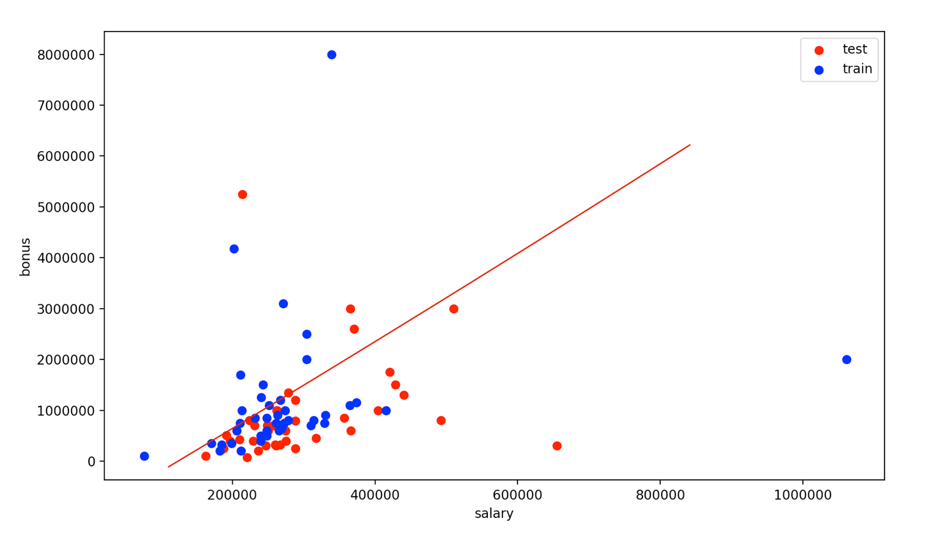

1. Import *LinearRegression* from sklearn, and create/fit your regression. Name it reg so that the plotting code will show it overlaid on the scatterplot. Does it fall approximately where you expected it?

**Copy and paste your added code here: (2)**

**from sklearn.linear_model import LinearRegression**

**reg = LinearRegression()**

**reg.fit(feature_train, target_train)**

**Attach a screenshot of your plot here: (2)**

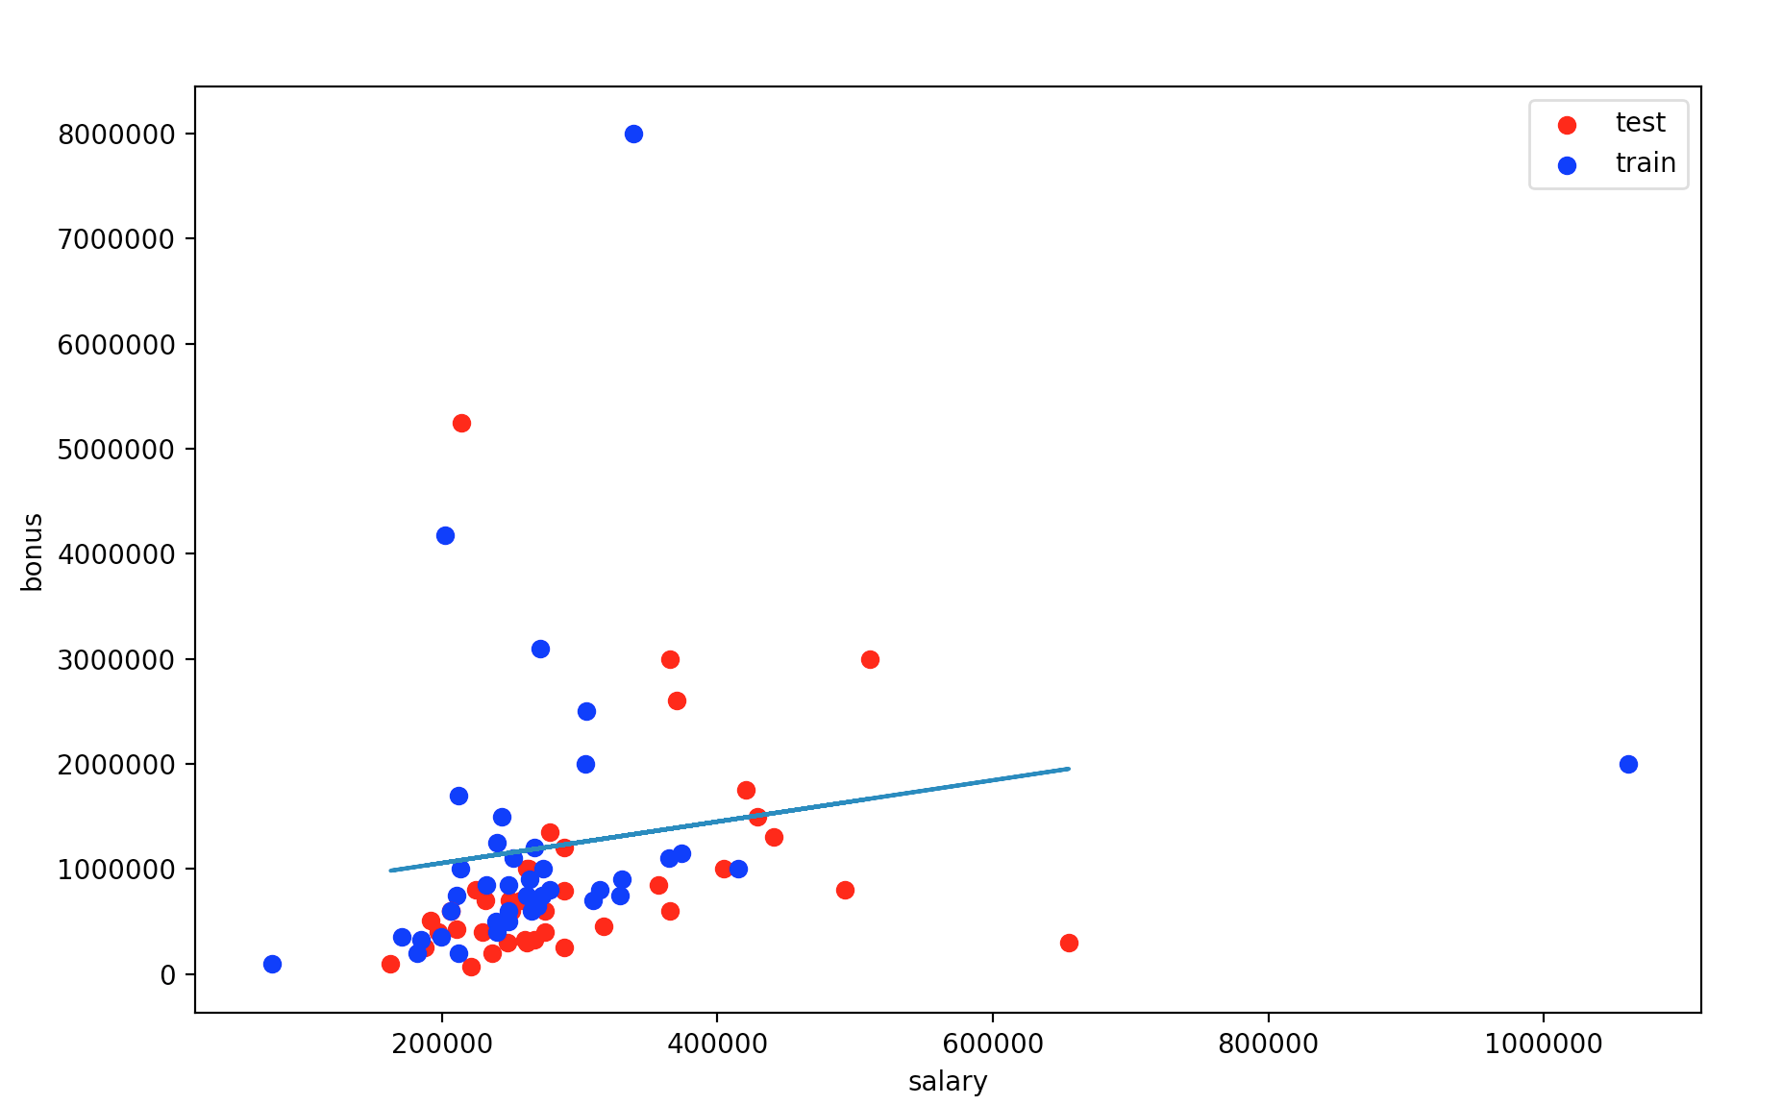

1. Extract the slope (stored in the *reg.coef_* attribute) and the intercept.  **What are the slope and intercept? (2)**

**Intercept = 662220.4176015807**

**Slope = [1.97017287]**

1. Imagine you were a less savvy machine learner, and didn’t know to test on a holdout test set. Instead, you tested on the same data that you used to train, by comparing the regression predictions to the target values (i.e. bonuses) in the training data.  **What score do you find? (1)**

**0.04164573226747781**

1. Now compute the score for your regression on the test data, like you know you should.  **What’s that score on the testing data?(2)**

**-0.04471207836147806**

1. **If you made the mistake of only assessing on the training data, would you overestimate or underestimate the performance of your regression? (2)**

**With the training data, we overestimated the regression since it gives positive 0.04. When the test data set was used, regression performance is worse both compare to test data as well as the mean variance.**

1. There are lots of finance features available, some of which might be more powerful than others in terms of predicting a person’s bonus. For example, suppose you thought about the data a bit and guess that the “long_term_incentive” feature, which is supposed to reward employees for contributing to the long-term health of the company, might be more closely related to a person’s bonus than their salary is. A way to confirm that you’re right in this hypothesis is to regress the bonus against the long term incentive, and see if the regression score is significantly higher than regressing the bonus against the salary. Perform the regression of bonus against long term incentive.

**Add your change in code here: (1)**

**The only line that changes is**

**features_list = ["bonus", "long_term_incentive"]**

1. **what’s the score on the test data? (1)**

**0.10891175736247383**

1. If you had to predict someone’s bonus and you could only have one piece of information about them, **would you rather know their salary or the long term incentive that they received?**

**Long term incentive is better predictor of the bonus because bonus and long term incentive relationship accounts for 10.89% of variation in data. Whereas, salary and long term incentive relationship is worse than that of the horizontal straight line (the null hypothesis) which is why its negative 0.04.**

1. Go back to a setup where you are using the salary to predict the bonus, and rerun the code to remind yourself of what the data look like. You might notice a few data points that fall outside the main trend, someone who gets a high salary (over a million dollars!) but a relatively small bonus. This is an example of an outlier. A point like this can have a big effect on a regression: if it falls in the training set, it can have a significant effect on the slope/intercept. If it falls in the test set, it can make the score much lower than it would otherwise be As things stand right now, this point falls into the test set (and probably hurting the score on our test data as a result). Let’s add a little hack to see what happens if it falls in the training set instead. Add these two lines near the bottom of *finance_regression.py*, right before *plt.xlabel(features_list[1])*:

*reg.fit(feature_test, target_test)*

*plt.plot(feature_train, reg.predict(feature_train), color="b")*

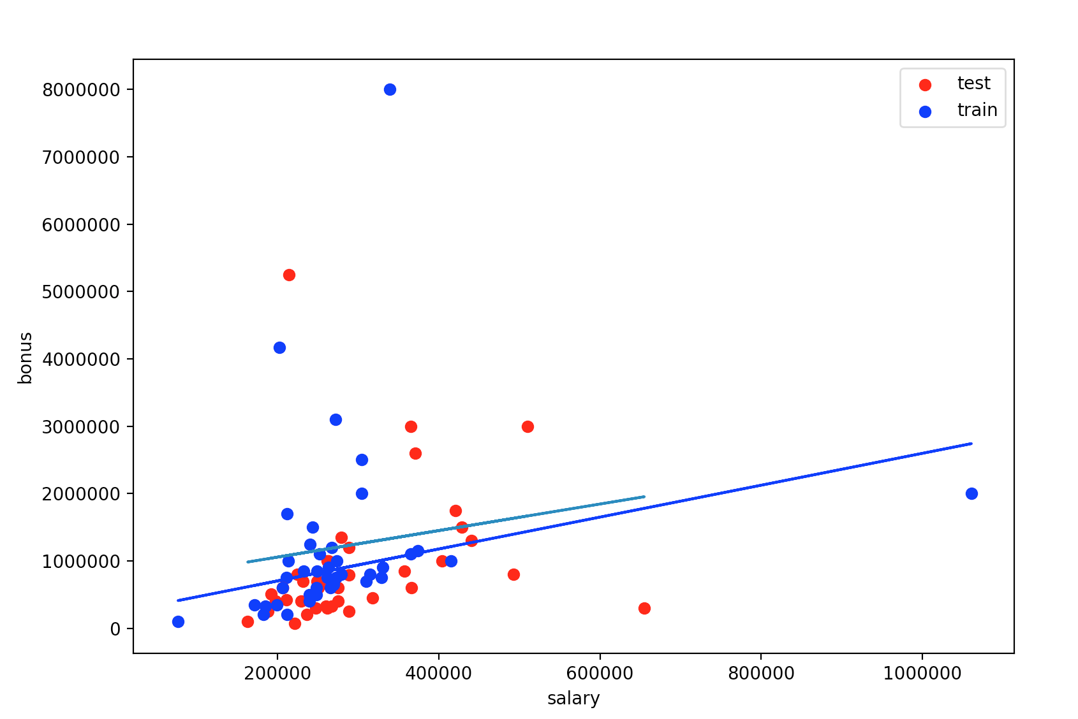

1. Now we’ll be drawing two regression lines, one fit on the test data (with outlier) and one fit on the training data (no outlier). Look at the plot now--big difference, huh? That single outlier is driving most of the difference.  **What’s the slope of the new regression line? (1)**

**The slope is [2.36761212]**

1. That’s a big difference, and it’s mostly driven by the outliers. There are tools to detect and deal with outliers. **Do a small research and provide a short explanation (about 3 lines) of a method to deal with outliers. (2)**

**There are multiple ways to deal with outliers such as robust regression which reduces the effect of outliers in order to fit majority of the data. There multiple ways to do such as Huber loss which optimizes the squared loss and absolute loss for the samples based on epsilon. Another way is** [**RANSAC**](https://scikit-learn.org/stable/modules/generated/sklearn.linear_model.RANSACRegressor.html#sklearn.linear_model.RANSACRegressor)**(RANdom SAmple Consensus) algorithm which divides data in two subsets : outlier and inlier, then it uses inlier set to fit model. Similarly, another model is to use Theil-Sen Regression. Some code for implementation is shown below.**

**from** sklearn.linear_model **import** (LinearRegression,

TheilSenRegressor,

RANSACRegressor,

HuberRegressor)

**from** sklearn.metrics **import** mean_squared_error

**from** sklearn.preprocessing **import** PolynomialFeatures

**from** sklearn.pipeline **import** make_pipeline

Source: https://ostwalprasad.github.io/machine-learning/Robust-Regression-models-using-scikit-learn.html